Ideation Phase
Define the Problem Statements

Date | 29 september 2026
Team ID | 6ab3db0c6603573ccfb381c9
Project Name | AI WEATHER WISE
Maximum Marks | 2 Marks

Customer Problem Statement
Weather information is important for people to plan their daily activities, travel, outdoor events, and safety. However, users may find it difficult to get accurate, real-time, and easy-to-understand weather information from different sources.
AI WeatherWise addresses this problem by providing real-time weather data, forecasts, alerts, and useful weather insights through API integration. It helps users understand upcoming weather conditions and make better decisions based on reliable weather information.
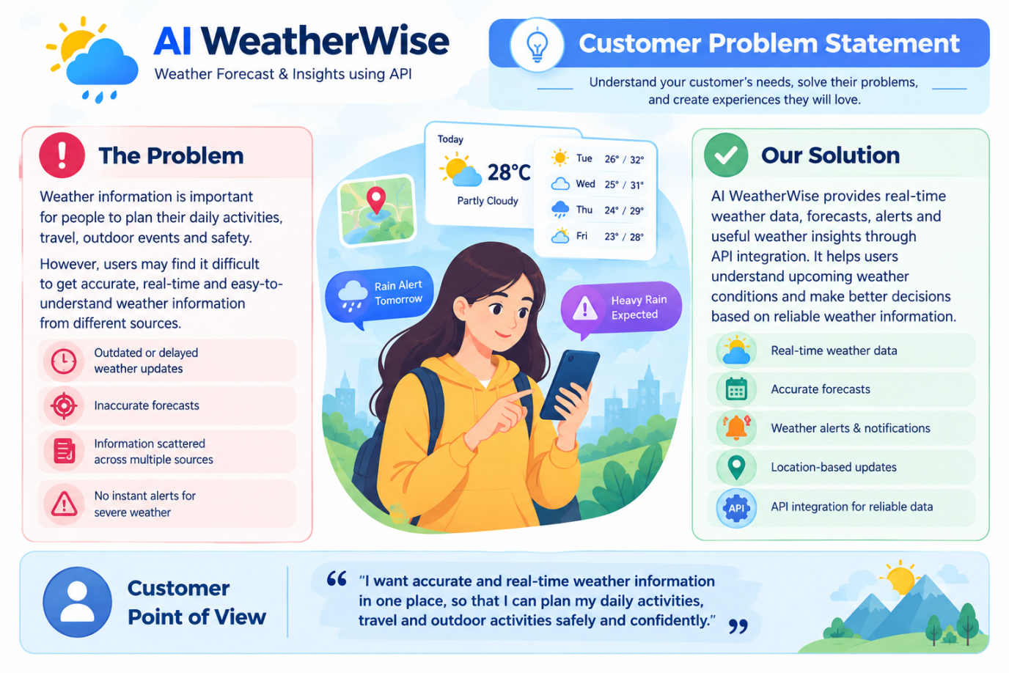

Example:
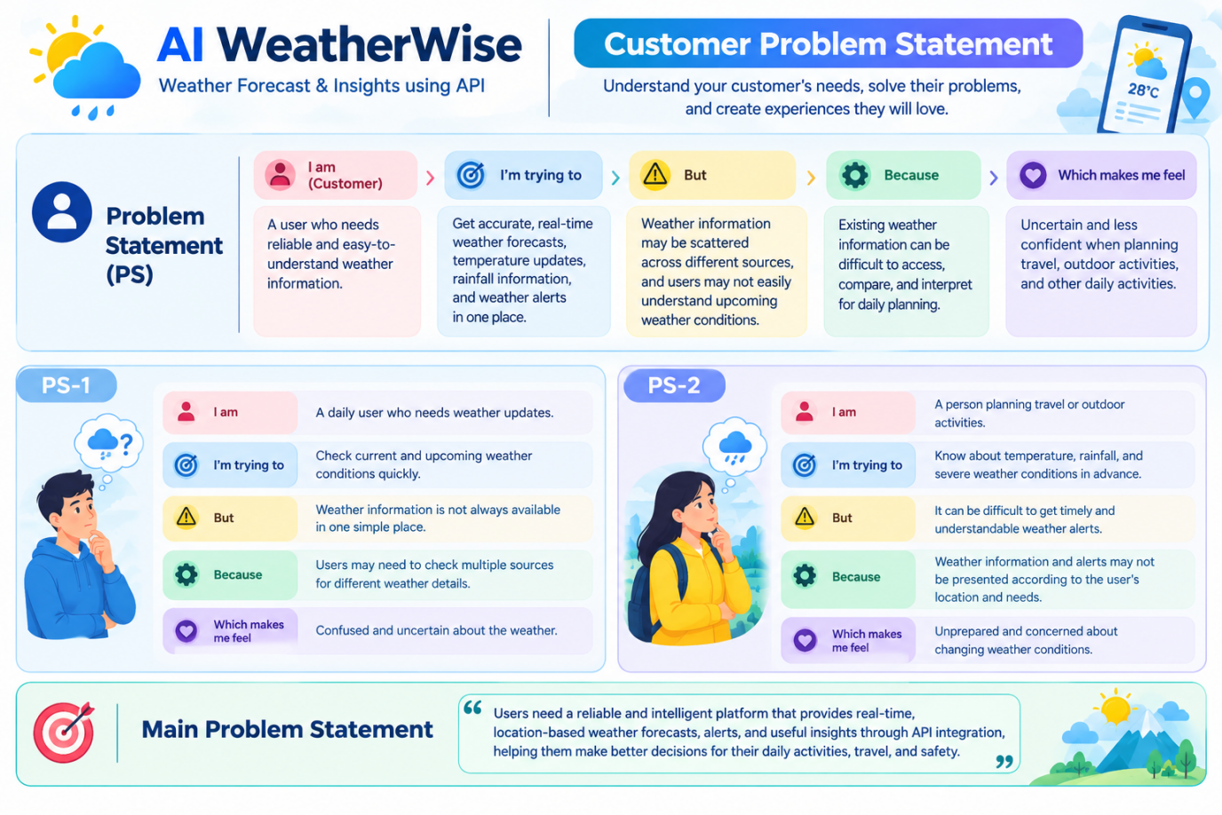
Problem Statement (PS) | I am (Customer) | I’m trying to | But | Because | Which makes me feel
PS-1 | I am a user who wants accurate and easy-to-understand weather information for daily activities | I’m trying to check the current weather, temperature, rainfall, and forecast before planning my activities. | But it is difficult to understand changing weather conditions and get all the required information in one place. | Because weather information may come from different sources and may not provide simple, personalized insights. | Which makes me feel confused and uncertain while planning travel, outdoor activities, work, and daily tasks.
PS-2 | AI can analyze weather data and provide intelligent forecasts. | The system can provide personalized weather insights to users. | The system can notify users about changing weather conditions. | Weather information can be displayed clearly in a user-friendly format. | AI WeatherWise can help users make better decisions using weather insights.

